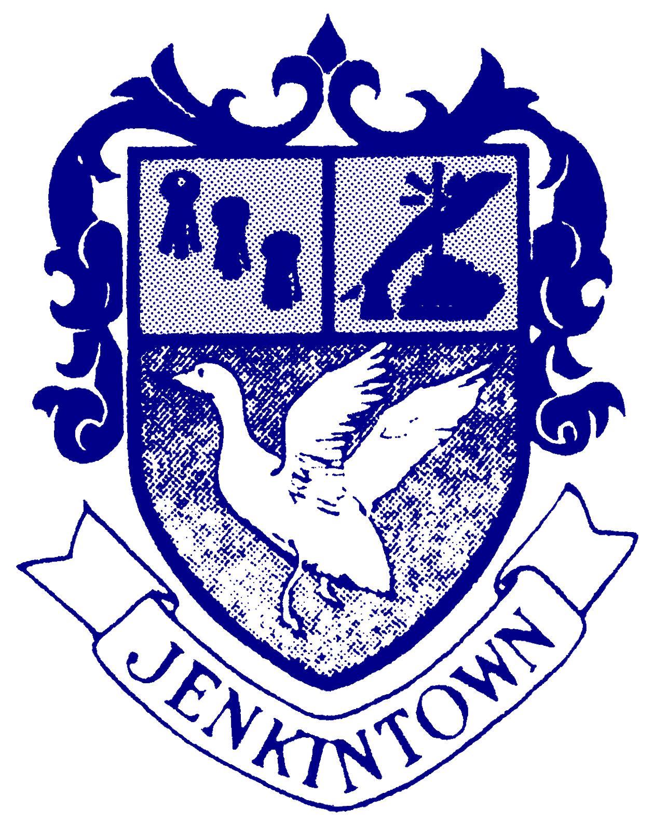 | Jenkintown Elementary School  West and Highland Avenue, Jenkintown, PA 19046-2698  Telephone (215) 884 – 2933, Ext. 121 www.jenkintown.org FAX(215)885-2090
Mr. Keith Purcaro, MS
Principal

November 5, 2015

Dear Parents/Guardians,
We welcome all families to join us in celebrating American Education Week, which will be recognized nationally during the week of Monday, November 16th, through Friday, November 20th. We offer an outstanding instructional program for all of our students, and we are proud to invite our parent community to see this program in action. We will be hosting parent visitations on Monday, November 16th, Tuesday, November 17th, and Wednesday, November 18th.
We have made some changes to the schedule and structure from previous years, so please be sure to note the visitation schedule on the second page of this letter. Visitation is spread out over the course of three days in an attempt to accommodate families with children in multiple grade levels. We welcome you to participate in classroom activities, but please do so in a manner that will maintain the integrity of the normal learning environment. To this extent, we also ask that you please refrain from bringing siblings with you to the visitation.
Due to the space constraints, it is very difficult to accommodate all of our visitors for lunch. For that reason, we do not be have a lunch visitation, but we invite all visitors to enjoy light refreshments in the Community Room before and/or after the visitation session.
We are very thankful for the overwhelming support of our community and for your commitment to an outstanding educational program. We believe that this visitation will give you the opportunity to experience a glimpse into what your children are doing in school on a daily basis. We included some suggestions that will help to make the day successful. We thank you for your support during this special visitation time.
We believe that your visit will enrich and enhance your understanding of our instructional program. We know that both the teachers and your child, in particular, will be looking forward to your visit during American Education Week.

Sincerely,
Keith L. Purcaro
Keith L. Purcaro
Principal

American Education Week Schedule
The elementary school will be open for visitation beginning at 8:45a.m. in the Community Room on Monday and Tuesday, and 9:45 on Wednesday. Please join us for refreshments before visiting the classrooms.
2010 American Education Week
Date Grade Visitation Time
Monday, November 15 K 9:00 a.m.- 9:45 a.m.
2 10:00 a.m.-10:45 a.m.
1 1:15 p.m. - 2:00p.m.

Tuesday, November 17 3 9:00 a.m.-10:00 a.m.
4 10:00 a.m-10:45 a.m.
Wednesday, November 18 5 & 6 10:00 a.m. - 11:00 a.m.

In order to assist your child’s teacher in maintaining a normal classroom schedule during visitation times, we would like to make the following suggestions:
1. We ask that cell phones be turned off while you are in the classroom visiting your children. In addition, cameras (including cell phone cameras) and video equipment should not be used during your classroom visit.
2. We ask that you please do not bring siblings during visitation.
3. Our cafeteria facilities are almost filled to capacity, which makes it a challenge to provide room for visitors. For this reason, we will not be hosting a lunch time visitation. We apologize for any inconvenience that this may cause.
4. While visiting the classrooms, we kindly ask that you refrain from talking during teacher instruction so that the instructional process can proceed as usual.
5. Please understand that this is an opportunity to observe the daily instructional program at Jenkintown Elementary School. If you have questions for the teacher, we ask that you call, e-mail, or address those questions during your scheduled conference on November 23rd or 24th.
6. Please feel free to arrive a little early and join us for refreshments in the Community Room before your visitation begins.

