Visiting author/illustrator
Bryan Collier
Book order form

The very talented Bryan Collier, author and illustrator of picture books for children will visit JES on Tuesday, March 15th!

Bryan Collier will present to all K-6 students about the art of researching, writing and illustrating picture books. He will also be autographing copies of his books. To order books, please complete the form below and return it to the library no later than Friday, March 7th. Please make checks payable to Bryan Collier. Additional books and art prints will be available for purchase during his visit. Mr. Collier will accept checks, credit cards and cash.

To learn more about Mr. Collier and his books, please visit the AUTHOR VISIT page of the Jenkintown Elementary Library website at:
http://mcnamarakristen.wix.com/jes-library - !author-visit-2016

BOOK | TITLE INFORMATION | # OF COPIES | AUTOGRAPH TO: | CIRCLE FORMAT
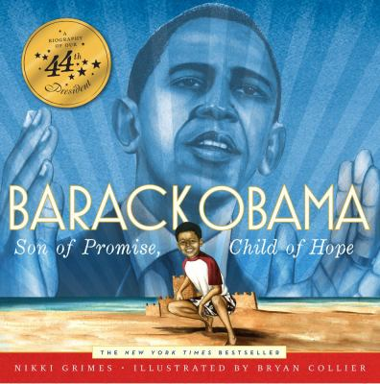 | Barak Obama  By Nikki Grimes  Ill: Bryan Collier  (2012) 34 p.  Reading Level 3.8 |  |  | Hardcover $15.00  Paperback $10.00
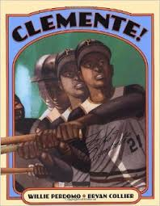 | Clemente  By Laban Karrik Hill  Ill: Bryan Collier  (2010) 32 p.  Reading Level 3.9 |  |  | Hardcover $15.00  Paperback $10.00
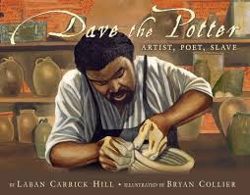 | Dave the Potter  By Laban Karrik Hill  Ill: Bryan Collier  (2010) 40 p.  Reading Level 5.6 |  |  | Hardcover $15.00  Paperback $10.00
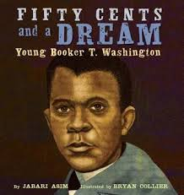 | Fifty Cents and a Dream  By Jabari Asim  Ill: Bryan Collier  (2012) 40 p.  Reading Level 4.6 |  |  | Hardcover $15.00  Paperback $10.00
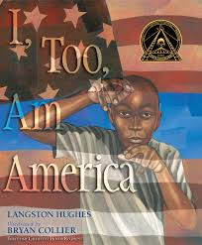 | I too am America  By Langston Hughes  Ill: Bryan Collier  (2012) 32 p.  Reading Level 2.4 |  |  | Hardcover $15.00  Paperback $10.00
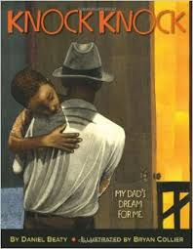 | Knock, Knock  By Daniel Beaty  Ill: Bryan Collier  (2013) 40 p.  Reading Level 2.9 |  |  | Hardcover $15.00  Paperback $10.00
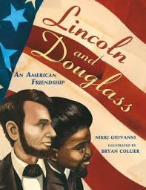 | Lincoln and Douglas  By Nikki Giovanni  Ill: Bryan Collier  (2008) 40 p.  Reading Level 4.9 |  |  | Hardcover $15.00  Paperback $10.00
 | Martin’s Big Words  By Doreen Rappaport  Ill: Bryan Collier  (2001) 40 p.  Reading Level 3.7 |  |  | Hardcover $15.00  Paperback $10.00
 | My Country ‘tis of thee  By Claire Rudolph Murphy  Ill: Bryan Collier  (2014) 48 p.  Reading Level 7.1 |  |  | Hardcover $15.00  Paperback $10.00
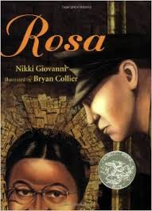 | Rosa  By Nikki Giovanni  Ill: Bryan Collier  (2007) 40 p.  Reading Level 5.2 |  |  | Hardcover $15.00  Paperback $10.00
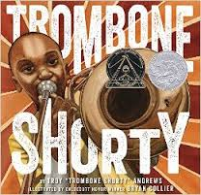 | Your Moon, My Moon  By Troy Andrews  Ill: Bryan Collier  (2015) 32 p.  Reading Level 4.0 |  |  | Hardcover $15.00  Paperback $10.00
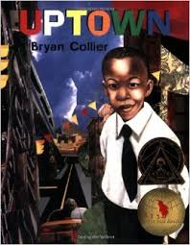 | Uptown  By Bryan Collier  (2000) 32 p.  Reading Level 3.0 |  |  | Hardcover $15.00  Paperback $10.00
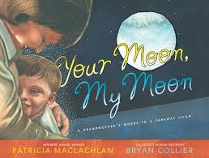 | Your Moon, My Moon  By Patricia MacLachlan  Ill: Bryan Collier  (2011) 32 p.  Reading Level 1.8 |  |  | Hardcover $15.00  Paperback $10.00
TOTAL NUMBER OF BOOKS: |  |  | TOTAL COST:

Make checks payable to Bryan Collier

Name _____________________________________________ Home __________________________

Please return this form to the ES Library. Orders due March 7th

